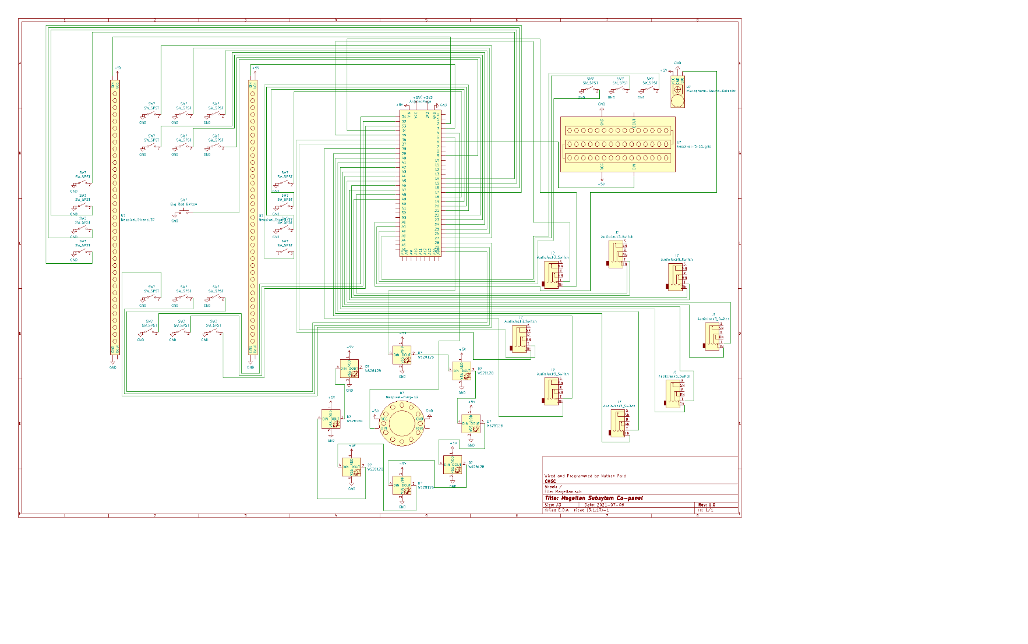Magellan Subsystem Wiring

* Light Strips
* Jack Wheel
* Oscilloscope

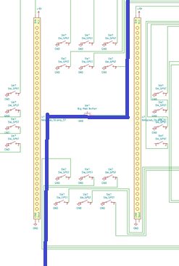Light Strips

The light strips are what I consider to be the bread and butter of this panel, these are what takes up most of the space on the panel, and are much of the visual effects on this panel.

The wiring of this is mirrored in a way think of it like this, it is cut kind of down the middle, but the top goes to the left and the bottom to the right (shown on the right). Do note that the Big Red Button Affects both sides though.

Pins

6-Switches- Remember one side goes to ground and the other pin to the Arduino.

|  |  |  |
| --- | --- | --- |
| **Switch placement** | **Side 1 Arduino Pin** | **Side 2 Arduino Pin** |
| Top left | 22 | 28 |
| Top middle | 23 | 29 |
| Top right | 24 | 30 |
| Bottom left | 25 | 31 |
| Bottom middle | 26 | 32 |
| Bottom right | 27 | 33 |